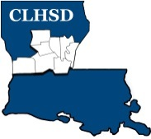
Central Louisiana Human Services District
Board Meeting Agenda
February 3, 2022
- Call to Order/Quorum
- Prayer/Pledge

- Read and Approve February 2022 Meeting Agenda (Vote)
Solicit Public Comment Requests

- Approval of Minutes (Vote)

January 2022 Board Meeting Minutes
- District Reports

  - Financial Report- (Vote) H1

  - ED Monthly Report H2

- Policy Reviews

Executive Limits:

  - II. E. Financial Condition & Activities w/corresponding procedure – Non Appropriated Funds - H3

- Board Business
  - Members Term Wishes –H4
  - Annual Bylaws Review – 2021 Kathy Scarborough, Committee Chair
C. Board Development/Training Topic –Residential Treatment

- Questions/Comments as Solicited

- Next Month – March

- Executive Limits – No Executive Limits
- Board Business - Annual Retreat – To be discussed
- Complete and communicate performance evaluation of ED

- Training Topic – No training topic

- Announcements
Next meeting – March 3, 2022

Adjourn (Vote)

